AI-Driven Voice and Speech Analytics in Call Centers
Integrating Conversational AI Data Analytics ERP Systems and Information Security for Digital Transformation
Mohamed Nabil Sayed Fouad
MBA Student AASTMT- Smart Village
ID : 23227310
mohelseufi@gmail.com
Prof. Ahmed ElSeddawy
Vice Dean of Educational Affairs- Smart Village
Ahmed.Bahgat@aast.edu

Abstract
Artificial Intelligence (AI) is rapidly reshaping how organizations manage customer service operations. In particular call centers generate enormous volumes of conversational data every day much of it in the form of voice interactions between customers and service agents. Hidden within these conversations are valuable signals about customer satisfaction service quality and operational performance.
This research explores how AI-driven speech analytics can be applied within call center environments and how these technologies contribute to digital transformation when integrated with enterprise systems such as Enterprise Resource Planning (ERP). The study analyzes a dataset of roughly 60,000 customer service interactions obtained from Kaggle in order to identify behavioral indicators related to dissatisfaction and potential customer churn.
To evaluate predictive performance machine-learning metrics such as ROC-AUC and F1-score were applied. The processed data was then visualized using Power BI dashboards to highlight operational patterns and provide managerial insights.
The results suggest that conversational analytics significantly improve an organization’s ability to monitor service quality detect dissatisfaction signals early and support proactive customer management strategies. In addition the study proposes an AI–ERP conversational intelligence framework that integrates speech analytics with enterprise decision systems while aligning with ISO 27001 information security practices. Overall the findings emphasize the growing strategic importance of voice analytics as organizations pursue digital transformation initiatives.
Keywords
Artificial Intelligence , Speech Analytics , Conversational AI ,Call Centers , Digital Transformation ERP Systems , Sentiment Analysis , Predictive Analytics

1. Introduction
Customer service operations have evolved significantly over the past decade largely due to the rapid development of Artificial Intelligence (AI) technologies. Organizations increasingly rely on AI-driven analytics systems to enhance operational efficiency improve customer engagement and support data-driven decision-making processes (Davenport & Ronanki 2018). As businesses become more digitally oriented the ability to analyze and interpret customer interaction data has become a critical factor in maintaining competitiveness and delivering high-quality service experiences.
Call centers remain one of the most important communication channels between organizations and their customers. Every day thousands of voice interactions take place between service agents and clients. These conversations generate large volumes of data that contain valuable insights into customer satisfaction service performance and potential operational issues. Traditionally call center performance has been evaluated using operational indicators such as Average Handling Time (AHT) Customer Satisfaction Score (CSAT) and First Call Resolution (FCR). While these metrics provide useful information about service efficiency they offer limited visibility into the deeper behavioral and emotional aspects of customer interactions.
Customer service environments have become increasingly competitive as organizations compete not only on product quality but also on the quality as well as the responsiveness and efficiency of their customer support services. In industries such as telecommunications banking and e-commerce customer experience has become a major differentiating factor. Organizations that fail to respond quickly to customer needs risk losing customers to competitors offering faster and more personalized support. As a result companies are investing in digital technologies such as artificial intelligence data analytics and automation to enhance service delivery and improve operational efficiency.
However traditional performance indicators primarily focus on operational efficiency rather than the emotional dynamics present within customer conversations. Important signals—such as frustration dissatisfaction or confusion—are often embedded within the dialogue itself and may not be captured through standard operational metrics. Consequently, organizations might miss important insights that could enable them to recognize developing service problems or uncover customers at risk of dissatisfaction.
Recent advancements in Automatic Speech Recognition (ASR) technology have made it possible to convert large volumes of voice recordings into structured textual data that can be analyzed more effectively (Bansal 2022). Once these conversations are transcribed into text Natural Language Processing (NLP) techniques can be applied to detect sentiment patterns identify recurring service problems and evaluate the overall customer experience. These analytical capabilities allow organizations to examine customer interactions at scale and uncover patterns that would be difficult to detect through manual monitoring processes.
In addition to analytical capabilities conversational AI technologies have enabled the development of intelligent voice agents capable of interacting with customers through natural language interfaces. These systems can assist human agents automate routine service requests and improve the scalability of customer support operations (Henkens et al. 2026). By combining speech recognition machine learning and conversational interfaces organizations can create more responsive and data-driven service environments.
Given these developments conversational data has become an increasingly valuable strategic resource for organizations seeking to improve customer service performance and operational decision-making. AI-driven speech analytics offers the potential to transform traditional call center environments into intelligent systems capable of continuously monitoring interactions identifying service issues and supporting proactive customer management strategies.
This study therefore investigates how AI-driven speech analytics can transform call center operations and how conversational data can be integrated with enterprise systems such as Enterprise Resource Planning (ERP) platforms to support more informed and strategic decision-making within service organizations.
2. Literature Review
Speech analytics has become an increasingly important technology for analyzing large volumes of conversational data in customer service environments. As organizations generate thousands of customer interactions daily manually reviewing these conversations has become both time-consuming and inefficient. Speech analytics systems address this challenge by using Automatic Speech Recognition (ASR) technologies to convert recorded voice interactions into textual transcripts that can be analyzed using advanced data analytics methods (Bansal 2022). This transformation of audio data into structured text enables organizations to apply computational techniques to identify patterns and insights within customer conversations.
Once speech data is transcribed machine learning algorithms can be applied to analyze the content of conversations and extract meaningful information. These models are capable of identifying sentiment patterns detecting potential service issues and evaluating agent performance based on communication quality and interaction outcomes. Compared with traditional monitoring methods that rely on manually reviewing a small sample of calls automated speech analytics allows organizations to analyze significantly larger volumes of customer interactions. This scalable approach improves the accuracy of service monitoring and provides a more comprehensive understanding of customer experience.
Natural Language Processing (NLP) techniques play a central role in the effectiveness of speech analytics systems. NLP methods enable computers to understand interpret and analyze human language in a structured way. Through techniques such as sentiment analysis keyword extraction and topic modeling organizations can identify recurring service problems detect emerging customer concerns and better understand the emotional tone present in conversations. These analytical capabilities allow organizations to move beyond simple operational metrics and gain deeper insights into customer behavior and expectations.
Conversational AI systems extend these capabilities even further by enabling automated dialogue interactions between machines and customers. AI voice agents integrate speech recognition language understanding and machine learning technologies to create intelligent systems capable of communicating with users in natural language (Henkens et al. 2026). These systems can assist human service agents by providing recommendations during conversations automate routine customer requests or in some cases manage entire service interactions independently. As conversational AI technologies continue to evolve they are increasingly being integrated into customer service platforms to enhance efficiency and improve response times.
Another significant development in this area is the use of sentiment analysis models to detect early signs of customer dissatisfaction. Instead of relying solely on formal complaints or customer surveys organizations can analyze emotional signals embedded within conversations. Machine learning models trained on labeled datasets can classify customer sentiment as positive neutral or negative allowing companies to identify potentially problematic interactions in real time. Detecting dissatisfaction early enables organizations to intervene proactively and address issues before they escalate thereby reducing the risk of customer churn and improving long-term service outcomes (Dzreke & Dzreke 2025).
In addition to improving service monitoring speech analytics technologies contribute to broader organizational decision-making processes. Insights derived from conversational data can reveal trends related to product issues service delays or customer expectations. By aggregating and analyzing these insights organizations can identify recurring problems and make informed strategic decisions to improve service quality. This data-driven approach allows companies to better align operational processes with customer needs and continuously refine their service strategies.
Overall the growing adoption of speech analytics machine learning and conversational AI technologies is transforming the way organizations manage customer service operations. Rather than relying on reactive approaches that address issues only after they occur modern service organizations are increasingly adopting predictive and data-driven models that enable them to anticipate customer needs detect service problems earlier and continuously improve the overall customer experience.
3. Research Methodology
This research adopts a data-driven case study approach to examine how speech analytics technologies can be applied within call center environments. The objective of this methodology is to analyze conversational data generated during customer interactions and evaluate how analytical models can identify patterns related to customer satisfaction service performance and potential customer churn.
3.1. Dataset Description and Processing Workflow
The dataset used in this study contains approximately 60,000 call center interactions obtained from Kaggle. The dataset includes several types of information related to customer service operations. Structured attributes include operational indicators such as call duration call outcomes and escalation indicators. In addition the dataset contains semi-structured conversational transcripts generated through speech-to-text processing technologies. These transcripts represent the textual form of voice conversations between service agents and customers providing valuable content for sentiment and behavioral analysis.
Step 1: Data Collection
The dataset was collected from Kaggle and includes customer interaction records.
Step 2: Data Understanding
The dataset contains:
- Call duration
- Call outcomes
- Escalation indicators
- Textual transcripts
Step 3: Data Preprocessing
- Managing incomplete or missing data
- Verifying and ensuring the accuracy of categorical variables
- Ensuring consistency
Step 4: Feature Preparation
Relevant variables were prepared for analysis.
Step 5: Model Application
Machine learning approaches were employed.
Step 6: Evaluation
- ROC-AUC
- F1-score
Step 7: Visualization
Power BI dashboards were used.
Before conducting the analytical procedures the dataset underwent several preprocessing steps to ensure data quality and reliability. Data preprocessing is a critical stage in machine learning workflows because inconsistencies or missing information can significantly affect the accuracy of predictive models. The following preprocessing procedures were applied:
• Handling missing values to ensure completeness of the dataset
• Validating categorical variables and ensuring consistent labeling across records
• Ensuring consistency across operational metrics such as call duration and escalation indicators
These steps helped ensure that the dataset was reliable and suitable for further analytical processing.
After the preprocessing phase machine learning models were applied to analyze the conversational data and identify patterns associated with customer sentiment and service outcomes. In predictive analytics research model evaluation is essential to determine the reliability and effectiveness of the predictive algorithms used. To evaluate the predictive performance of the models two widely used performance metrics were applied:
• ROC-AUC (Receiver Operating Characteristic – Area Under Curve)
• F1-score
it is important to understand how model performance is assessed. The following figures illustrate the evaluation metrics used to measure the effectiveness of the predictive models.

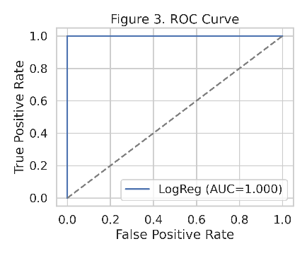

Figure 1: ROC Curve for Model Performance Evaluation [Author]
The ROC curve in Figure 1 represents the model's ability to distinguish between different classes by plotting true the true positive rate plotted against the false positive rate , A higher AUC indicates better performance.
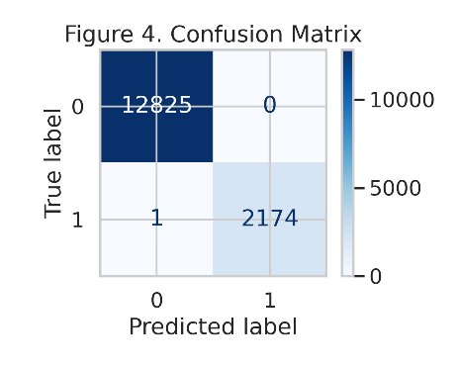

Figure 2: F1-Score Evaluation Metric [Author]
The F1-score balances precision and recall in Figure 2 , making it useful for imbalanced datasets. Greater values reflect improved model performance..
In addition to predictive modeling several data mining techniques can be applied to conversational datasets to extract meaningful knowledge from customer interactions. Classification techniques are commonly used to categorize customer sentiment or service outcomes based on historical training data. For example machine learning models can classify conversations as positive neutral or negative according to the detected emotional tone of the interaction. Clustering techniques can also be applied to group similar conversations together in order to identify recurring patterns of customer complaints or service issues. By analyzing clusters of conversations organizations can detect hidden trends that may not be visible through traditional reporting methods. Furthermore association rule mining can be used to discover relationships between different service factors such as identifying combinations of service issues that frequently occur together. These data mining approaches enhance the ability of organizations to transform large volumes of conversational data into actionable findings that help inform strategic decision-making
Following the evaluation of the predictive models the processed dataset was imported into Microsoft Power BI to develop interactive dashboards for data visualization. Data visualization plays an important role in translating analytical results into meaningful insights for decision-makers. Through visual dashboards service managers can monitor operational indicators observe patterns in customer interactions and identify trends related to service performance and customer sentiment.
The analytical workflow in this research follows four main stages of data analytics commonly used in business intelligence frameworks:
- Descriptive analytics which focuses on summarizing historical data to understand what has occurred within call center operations.
- Diagnostic analytics which aims to identify the underlying causes behind observed operational patterns or service issues.
- Predictive analytics which uses machine learning models to forecast potential outcomes such as customer dissatisfaction or churn risk.
- Prescriptive analytics which supports decision-making by recommending potential actions that organizations can take to improve service performance.
By combining these analytical stages the research framework provides a comprehensive approach for examining customer interactions and extracting actionable insights from conversational data generated in call center environments.
To better understand the analytical insights derived from the dataset, Power BI dashboards were developed.
1st Descriptive analytics:
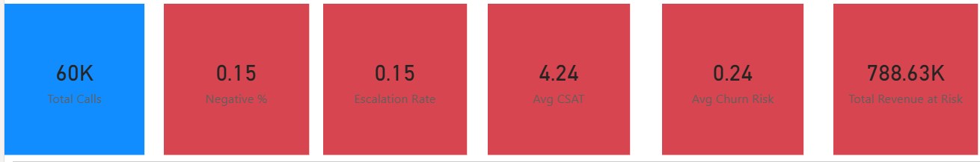
Figure 3 Shows historical performance such as call volume and duration.

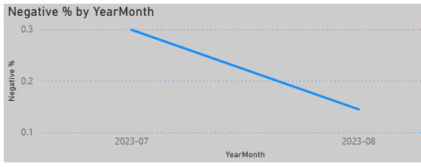
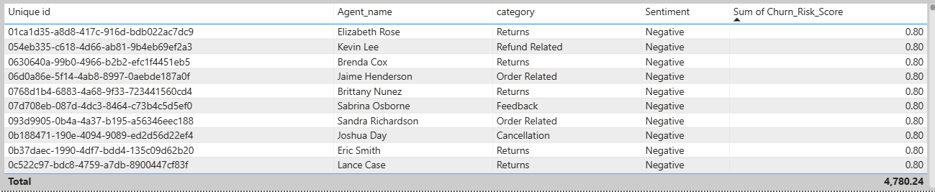
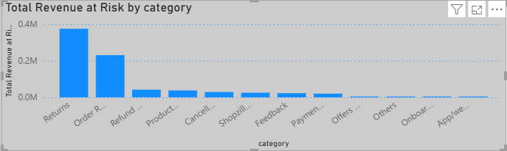

Figure 3: Descriptive Analytics Dashboard [Author]

2nd Diagnostic analytics :
Figure 4 Identifies causes behind trends such as high escalation rates
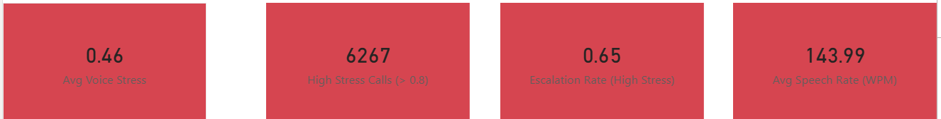

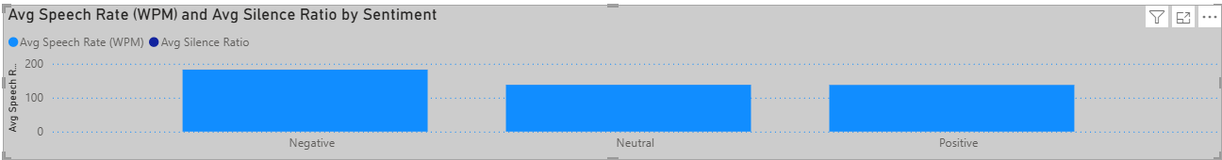

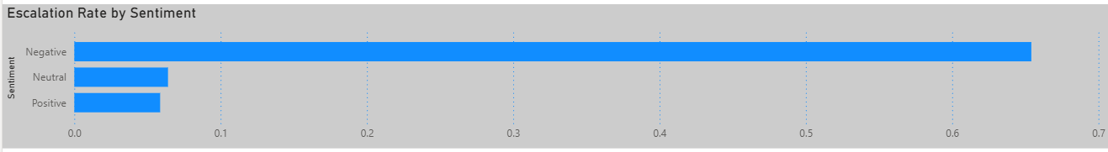
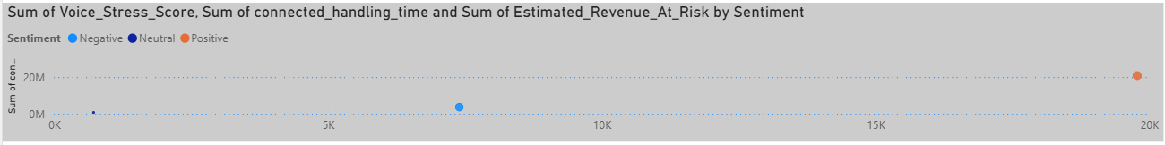

Figure 4: Diagnostic Analytics Dashboard [Author]
3rd Predictive analytics 4th Prescriptive analytics :
Figure 5 Displays predicted churn and dissatisfaction. Figure 6 Suggests actions based on predictions


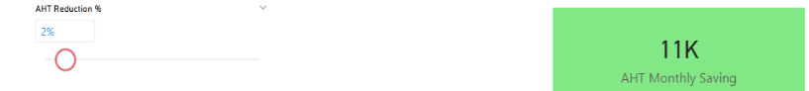
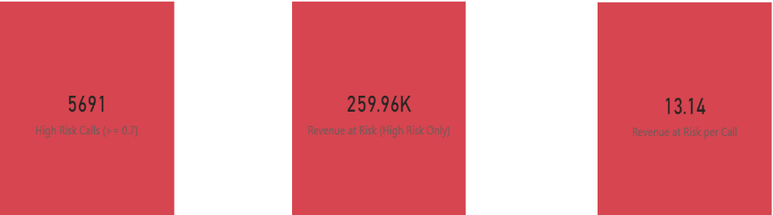

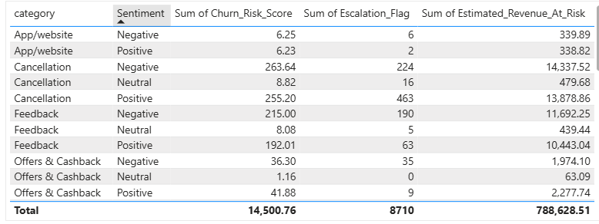

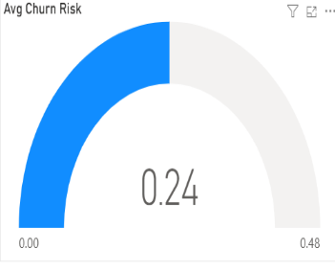




Figure 5 : Predictive Analytics Dashboard Figure 6: Prescriptive Analytics Dashboard

4. AI and Data Analytics Application
Speech analytics systems analyze conversational data generated during customer interactions and transform voice recordings into structured datasets that can be analyzed through sophisticated analytical methods. In traditional call center environments large volumes of voice data are generated daily but much of this information often remains underutilized because manual review processes are limited in scale. By applying speech analytics technologies organizations can convert voice conversations into machine-readable text through Automatic Speech Recognition (ASR) enabling further analysis using data analytics and machine learning techniques.
The implementation of AI-driven speech analytics systems typically follows the System Development Life Cycle (SDLC) which provides a structured framework for developing and deploying information systems. The first phase is the planning stage where organizations identify the business problem and evaluate how AI technologies can support operational improvement. During the analysis phase system requirements are defined including the type of conversational data that must be collected and processed. The design phase focuses on developing the architecture of the analytics system including the integration of speech recognition machine learning models and enterprise platforms. In the development phase machine learning algorithms are trained using historical datasets to detect patterns such as customer sentiment or dissatisfaction signals. The testing phase ensures that the analytical models and system components perform reliably before deployment. Finally during the implementation and maintenance phase the system is integrated with operational platforms such as CRM and ERP systems while continuously monitoring performance and updating models as new data becomes available.
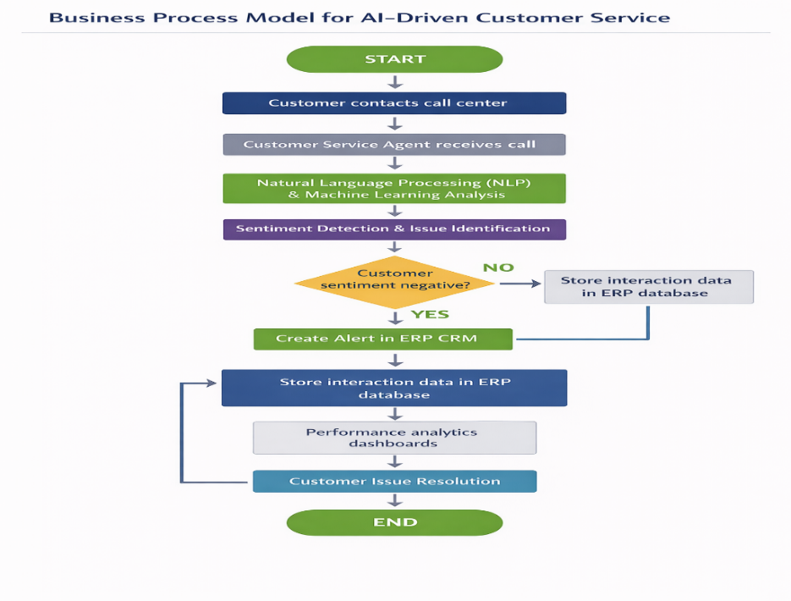
To illustrate how AI-driven speech analytics operates, the following workflow diagram presents the full process

Figure 7: Business Process Model for AI-Driven Customer Service [Author]

This business process model in Figure 7 illustrates how customer interactions are processed within an AI-enabled service environment. Customer calls are recorded and analyzed using speech analytics technologies. When negative sentiment or service issues are detected automated alerts are generated within the ERP system to enable timely intervention and improved service resolution.
Once customer conversations are transcribed into textual form analytical models can examine the content of these interactions to evaluate emotional tone detect recurring service issues and identify behavioral patterns related to customer dissatisfaction. These insights allow organizations to better understand customer needs monitor service quality and identify potential operational problems that may remain undetected when relying solely on conventional performance metrics.
Machine learning models play a central role in extracting meaningful insights from conversational datasets. In speech analytics applications supervised learning techniques are commonly used to classify customer sentiment based on labeled training data. These models can categorize customer interactions as positive neutral or negative allowing organizations to quickly identify conversations that may indicate dissatisfaction or service failure. Sentiment classification models are particularly valuable for large-scale monitoring of customer experience because they enable automated analysis of a large volume of interactions within a short period of time.
In addition to supervised learning methods unsupervised learning techniques are frequently applied to identify hidden patterns within conversational datasets. These techniques can detect clusters of similar customer complaints identify frequently occurring service issues and uncover previously unknown patterns within customer interactions. By analyzing these patterns organizations can gain deeper insights into recurring operational challenges and improve service processes accordingly.
Semi-supervised learning methods further improve the analytical power of speech analytics systems.In many real-world scenarios only a portion of conversational data may be labeled for training machine learning models. Semi-supervised methods allow systems to learn from both labeled and unlabeled datasets improving model performance while reducing the amount of effort needed for manual data labeling. This approach is particularly useful when analyzing large-scale conversational datasets where labeling every interaction would be impractical.
Beyond sentiment detection advanced speech analytics systems can also identify key conversational indicators such as escalation triggers repeated complaints and changes in customer tone throughout an interaction. These indicators help organizations detect service issues earlier and support proactive decision-making. When combined with visualization tools and enterprise systems the insights generated by speech analytics models can contribute to more informed operational strategies as well as enhanced management of the customer experience

Overall the integration of machine learning techniques with speech analytics technologies enables organizations to transform raw conversational data into actionable insights. By systematically analyzing customer interactions companies can better understand service performance anticipate potential problems and continuously improve the quality of their CS operations.
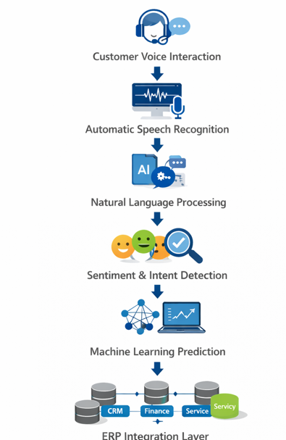

Figure 8: AI–ERP Conversational Intelligence Framework [Author]
This architecture in Figure- 8 illustrates how conversational data can move from raw voice recordings to enterprise-level decision systems.
Key Analytical Metrics
Metric | Description
Average Handling Time | Average duration of service interactions
Sentiment Score | Emotional tone detected in conversations
Escalation Rate | Percentage of calls escalated to supervisors
Churn Risk Score | Probability of customer churn
Revenue at Risk | Estimated financial exposure from dissatisfaction

These metrics allow organizations to evaluate both operational efficiency and customer behavior patterns.

5. Digital Transformation Analysis
The adoption of speech analytics technologies represents an important component of the broader digital transformation occurring in modern service organizations. Digital transformation involves not only the implementation of new technologies but also the redesign of operational processes and decision-making practices through data-driven approaches. In customer service environments AI-powered analytics tools allow organizations to analyze large volumes of interaction data and convert it into actionable insights that support service improvement and operational efficiency (Huang & Rust 2021).
Speech analytics technologies contribute significantly to this transformation by automating several processes that were traditionally performed manually. For example AI systems can automatically transcribe recorded calls analyze the emotional tone of customer interactions and identify service issues or dissatisfaction signals within conversations. By automating these analytical tasks organizations can monitor a much larger proportion of customer interactions compared with traditional quality assurance processes which often rely on reviewing only a small sample of calls.
In addition to improving monitoring capabilities speech analytics systems enable organizations to move toward more proactive service management. Instead of reacting to customer complaints after they occur companies can identify early warning signals of dissatisfaction directly within customer conversations. These insights allow service managers to intervene earlier resolve issues more effectively and improve overall customer satisfaction.
Alongside AI-driven analytics technologies many organizations are also adopting Robotic Process Automation (RPA) to automate repetitive operational tasks within call center environments. RPA software robots are designed to perform routine tasks that normally require human intervention such as updating customer records generating service tickets or initiating follow-up actions after customer interactions. When integrated with AI-based speech analytics systems RPA can automatically trigger operational responses based on insights derived from customer conversations.
For example if speech analytics models detect negative sentiment during a customer interaction the system may automatically create a follow-up case in the customer service platform or notify supervisors for further review. This integration between AI analytics and automation technologies enables organizations to create intelligent service workflows that improve responsiveness reduce manual workload and enhance operational efficiency.
Figure- 9 illustrates a digital transformation model in which conversational data flows through multiple analytical and operational layers. Voice interactions are first processed through speech recognition technologies then analyzed using machine learning models and finally integrated into organizational decision systems. Through this process conversational data becomes a strategic resource that supports continuous service improvement and more informed decision-making.

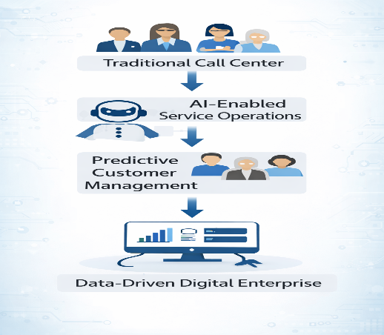

Figure 9: Digital Transformation Model [Author]
6. ERP Integration Model
In practical business environments the insights generated from conversational analytics systems often need to be integrated with enterprise management platforms to create real organizational value. One of the most important systems in this context is Enterprise Resource Planning (ERP) which serves as the central information infrastructure for many organizations. ERP systems integrate multiple business functions—including finance operations sales and customer relationship management—within a unified platform.
In this research conversational analytics insights are conceptually integrated with ERP modules implemented through the Odoo platform. Odoo provides several functional modules that support customer service and operational management including Customer Relationship Management (CRM) service management and financial reporting. By connecting speech analytics insights with these modules organizations can link customer interaction data directly to operational and strategic processes.
For instance sentiment analysis results derived from customer conversations can be integrated with CRM systems to update customer profiles or generate alerts when dissatisfaction signals are detected. This enables customer service teams to respond more quickly to emerging issues and improve overall customer relationship management. Similarly aggregated conversational insights may reveal recurring product or service issues which can then be communicated to operational or product development teams through the ERP system.
In addition integrating conversational analytics with ERP platforms enables organizations to connect customer experience insights with financial and operational performance indicators. For example if analytics models identify an increase in negative customer sentiment related to a particular service issue this information can be used by management to assess potential revenue risks and prioritize corrective actions.
Figure-10 illustrates the proposed AI–ERP data architecture in which conversational data collected from customer interactions flows through speech analytics systems and is then integrated into enterprise management platforms. This architecture enables organizations to transform raw conversational data into actionable knowledge that supports decision-making across multiple department

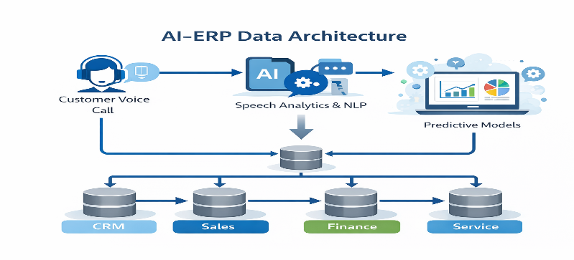

Figure 10: AI–ERP Data Architecture [Author]
The integration between speech analytics systems and ERP platforms can also be represented through a business process workflow that illustrates how conversational data moves across organizational systems. In this workflow customer voice interactions are first recorded during service calls and processed through speech recognition technologies to generate textual transcripts. These transcripts are then analyzed using machine learning models to detect sentiment patterns service issues or potential escalation indicators. The analytical results are subsequently transmitted to enterprise systems such as CRM modules within the ERP platform. Based on these insights automated workflows may be triggered such as generating customer service tickets notifying supervisors or updating customer profiles with risk indicators. This structured data flow enables organizations to transform raw conversational data into operational actions that support proactive customer service management.
7. Business Impact and Value Creation
The implementation of speech analytics technologies can generate significant operational and financial value for organizations that rely heavily on customer service operations. By converting large volumes of voice conversations into structured data organizations gain deeper visibility into how customers interact with their services and how service agents respond to different situations. This visibility enables companies to identify operational inefficiencies and improve overall service performance.
From an operational standpoint speech analytics improves the way organizations monitor and evaluate customer interactions. Traditional call center monitoring methods often rely on manually reviewing a small sample of calls for quality assurance purposes. This approach provides limited insight into overall service performance because only a small portion of conversations is analyzed. In contrast speech analytics systems allow organizations to automatically analyze a large percentage of customer interactions. This capability significantly enhances monitoring efficiency and allows managers to evaluate agent performance more consistently.
Another important benefit is the ability to detect recurring service issues more quickly. By analyzing conversation transcripts organizations can identify patterns in customer complaints detect frequently occurring service failures and understand common customer concerns. These insights allow service managers to implement improvements in operational processes and customer support procedures.
From a financial perspective predictive analytics models derived from speech analytics systems can help organizations identify early signals of customer dissatisfaction. Machine learning algorithms can analyze sentiment patterns within conversations and estimate the likelihood of customer churn. Detecting these signals early allows companies to take proactive actions such as offering targeted support or retention incentives which can help reduce customer churn and protect revenue streams (Rust & Huang 2014).
Furthermore the integration of conversational analytics with enterprise systems such as CRM and ERP platforms enables organizations to align customer service insights with broader business strategies. As a result speech analytics becomes not only a tool for improving service operations but also a strategic capability that supports long-term business value creation.
To illustrate the potential impact of implementing speech analytics technologies in call center environments Table 1 presents a simplified comparison between traditional call center operations and AI-enabled service operations.

Table 1: Operational Impact of Speech Analytics in Call Centers
Aspect | Before Speech Analytics | After Speech Analytics
Call Monitoring | Manual review of a small sample of calls | Automated analysis of big volumes of calls
Customer Insights | Limited understanding of customer sentiment | Real-time sentiment detection and behavioral insights
Issue Detection | Service problems identified after customer complaints | Early detection of dissatisfaction signals
Agent Performance Evaluation | Inconsistent evaluation based on limited call reviews | Data-driven performance monitoring
Decision Making | Reactive service management | Proactive and predictive service strategies
Customer Retention | Limited ability to identify churn risks | Predictive models identifying at risk customers
This comparison highlights how speech analytics technologies can transform traditional call center environments into more intelligent data-driven service operations. By leveraging conversational data at scale organizations can improve operational efficiency enhance customer experience and support more effective strategic decision-making.
8. Risks Ethical Issues and ISO 27001 Compliance
Despite the numerous advantages offered by conversational analytics technologies their implementation also raises important ethical legal and information security considerations. Customer voice recordings often contain sensitive personal information including account details service issues or private communications. As a result organizations that implement speech analytics systems must ensure that customer data is handled responsibly and protected against unauthorized access or misuse.
Data privacy is one of the primary concerns associated with large-scale conversational data analysis. Organizations must establish clear policies governing how voice recordings are collected stored processed and analyzed. In many jurisdictions regulatory frameworks require companies to inform customers that their calls may be recorded and analyzed for quality assurance or analytical purposes. Transparent communication with customers helps build trust while ensuring compliance with data protection regulations.
Another important challenge relates to ethical considerations in the use of artificial intelligence systems. Machine learning models applied to sentiment analysis or behavior prediction can introduce biases if the training data is not properly controlled or curated. Organizations must therefore ensure that AI systems are designed tested and monitored in ways that promote fairness transparency and accountability.
To address these concerns many organizations adopt internationally recognized information security standards. One widely used framework is ISO/IEC 27001 which provides guidelines for protecting organizational information assets through the implementation of an Information Security Management System (ISMS). This standard defines a structured approach for managing information security risks and ensuring that sensitive data is adequately protected.
Although AI-driven analytics and ERP systems provide significant operational benefits these technologies also have certain limitations that organizations must consider. Machine learning models rely heavily on the quality and accuracy of the data used for training. If the training dataset contains incomplete or biased information the resulting predictions may not accurately reflect real customer behavior. In addition AI models may struggle to correctly interpret complex conversational contexts sarcasm or culturally specific language expressions. ERP systems also present limitations particularly in terms of flexibility and scalability when integrating advanced AI technologies. Traditional ERP platforms were primarily designed to manage structured transactional data which can make integration with large conversational datasets technically challenging. As a result organizations must carefully evaluate system capabilities and ensure that adequate data governance and system monitoring mechanisms are in place.
Several ISO 27001 control areas are particularly relevnt for speech analytics systems including:
• Access Control (Clause A.9) – ensuring that only authorized personnel can access conversational data
• Operations Security (Clause A.12) – implementing procedures for secure processing and storage of data
• Compliance Requirements (Clause A.18) – ensuring that organizational practices align with legal and regulatory obligations
By implementing these controls organizations can ensure that conversational data is stored securely processed responsibly and accessed only by authorized individuals. This structured security approach helps organizations balance the benefits of conversational analytics with the need to protect customer privacy

9. Recommendations and Future Scope
The successful implementation of speech analytics technologies requires organizations to adopt clear governance structures and invest in supporting infrastructure.
The following table summarizes key organizational recommendations and potential future research directions related to speech analytics systems.
Table 2: Recommendations and Future Development Areas for Speech Analytics
Area | Recommendation / Future Direction | Expected Benefit
AI Governance | Establish governance frameworks to ensure responsible use of AI and conversational data. | Improves transparency accountability and ethical AI deployment.
Data Infrastructure | Develop robust data storage and processing systems to manage large conversational datasets. | Enables efficient data analysis and system scalability.
ERP Integration | Integrate speech analytics insights with enterprise systems such as CRM and ERP platforms. | Enhances decision-making and aligns customer insights with business operations.
Multilingual Speech Models | Invest in multilingual speech recognition technologies to support diverse customer populations. | Enhances both accessibility and precision across global service settings.
Emotion Recognition | Develop advanced AI models capable of detecting emotional signals during conversations. | Provides deeper insights into customer experience and satisfaction.
Real-Time Agent Support | Implement AI-powered recommendation systems that assist service agents during live interactions. | Improves response quality and customer satisfaction.
AI-Assisted Training | Introduce AI-based coaching tools that provide feedback and training for service agents. | Boosts agent effectiveness and overall service quality.

10. Conclusion
AI-driven speech analytics is rapidly becoming a critical capability for modern service organizations. As customer interactions increasingly generate large volumes of conversational data organizations must develop effective methods for transforming this information into actionable insights. Speech analytics technologies enable companies to convert voice interactions into structured analytical data that can reveal patterns related to customer behavior service quality and operational performance.
By applying machine learning and natural language processing techniques organizations can identify customer sentiment detect emerging service issues and anticipate potential dissatisfaction before it leads to customer churn. These capabilities allow companies to move beyond traditional operational metrics and adopt a more comprehensive understanding of customer experience.
When integrated with enterprise systems such as ERP platforms conversational analytics becomes even more powerful. Insights derived from customer interactions can influence operational decision-making financial planning and service strategy development across multiple departments. This integration enables organizations to align customer experience management with broader business objectives. The conversational intelligence framework proposed in this study demonstrates how voice analytics technologies can transform traditional call centers into intelligent service ecosystems. By combining speech analytics machine learning enterprise systems integration and strong information security practices organizations can build data-driven service environments capable of supporting modern digital business strategies.
References
Bansal, A. (2022). Revolutionizing call centers through ASR and advanced speech analytics. Journal of Customer Service Technology.
Cambria, E., & White, B. (2014). Jumping NLP curves: A review of natural language processing research. IEEE Computational Intelligence Magazine.
Chen, H., Chiang, R., & Storey, V. (2012). Business intelligence and analytics: From big data to big impact. MIS Quarterly, 36 (4), 1165–1188.
Davenport, T., & Ronanki, R. (2018). Artificial intelligence for the real world. Harvard Business Review, 96 (1), 108–116.
Dzreke, S., & Dzreke, S. (2025). Preventing complaints before they happen: AI-driven sentiment analysis in customer service environments. International Journal of Service Analytics.
Gartner. (2022). Market guide for speech analytics solutions. Gartner Research.
Henkens, B., Schultz, C., De Keyser, A., & Mahr, D. (2026). The sound of progress: AI voice agents in service. Journal of Service Research.
Huang, M., & Rust, R. (2021). Artificial intelligence in service. Journal of Service Research, 24 (1), 3–18.
IBM Institute for Business Value. (2021). Artificial intelligence for customer experience transformation
IBM. (2021). Artificial intelligence for customer experience transformation. IBM Institute for Business Value.
Jurafsky, D., & Martin, J. (2023). Speech and language processing. Pearson.
McKinsey & Company. (2023). The state of AI in customer service. McKinsey Global Institute.
Rust, R., & Huang, M. (2014). Artificial intelligence in service. Journal of Service Research, 17 (4), 321–334.

